|  |  |  |
| --- | --- | --- |
| **Course: WEB322 - Web Programming Tools and Frameworks** | **Assignment 2 of 5**  **(Ver1.1)** | **Contribution: 10% of final grade** |
| **Instructor: Wei Song** | **Date Given: October 9** | **Date Due: October 23** |

**Notes for the Student:** This Assignment is the second of five that is designed to give you practical experience in hosting Server-Side Web applications using a cloud based solution (Heroku) ,sending emails and applying server side form validation to your web application .

**Background**: You will need to have access to an IDE or text editor and have a thorough understanding of Node.js, Express, Git, GitHub (or Bitbucket) and Heroku.

## **Assignment Regulations**

* **This assignment must be done individually.**
* **Please review Seneca’s policies on Academic Integrity, specifically:**

*“Each student should be aware of the College's policy regarding Cheating and Plagiarism. Seneca's Academic Policy will be strictly enforced. To support academic honesty at Seneca College, all work submitted by students may be reviewed for authenticity and originality, utilizing software tools and third party services. Please visit the Academic Honesty site on http://library.senecacollege.ca for further information regarding cheating and plagiarism policies and procedures.”* ***Thus, ensure that your code or any part of it is not duplicated by another student(s). This will result in a percentage of zero (0%) assigned to all parties involved.***

**Technical Requirements**

* All back-end functionality **MUST** be done using **Node JS and Express**.
* Your views **MUST** be created with **Express-Handlebars**
* **You are not allowed to use any Front-End CSS or JavaScript Frameworks.**

# **Detailed App Specification**

This assignment is a continuation of Assignment 1 thus all the requirements for this assignment is to be made “on top” of your assignment 1.

Note, **no database connectivity is required for Assignment 2.**

|  |
| --- |
| REMINDER:  All back-end functionality **MUST** be done using **Node JS and Express**.  Your views **MUST** be created with **Express-Handlebars** |

# Features

# 

# Responsive Design

Ensure that your entire website renders well on a variety of devices, specifically on desktops, tablets, and smartphones. To accomplish this, you will need to use Bootstrap in your project.

# Server-Side Validation

* You are required to implement Server-Side validation for both the login and registration form. **NO HTML5 VALIDATION OR CLIENT-SIDE JS VALIDATION IS ALLOWED**
* For the login form, you are required to ONLY check for nulls (i.e. check to see if the user entered a value in the respective text fields). However, for the registration form, you have to check for nulls AND implement at least 2 complex validation criteria using regular expressions on two separate fields(For example, enforcing that the user must enter a password that is 6 to 12 characters and the password must have letters and numbers only) .
* Your form should not clear the data entered in the form if there are validation errors.
* All error messages must be rendered on their respective pages or areas and must be styled properly, like Figure 1.1

**Figure 1.1**

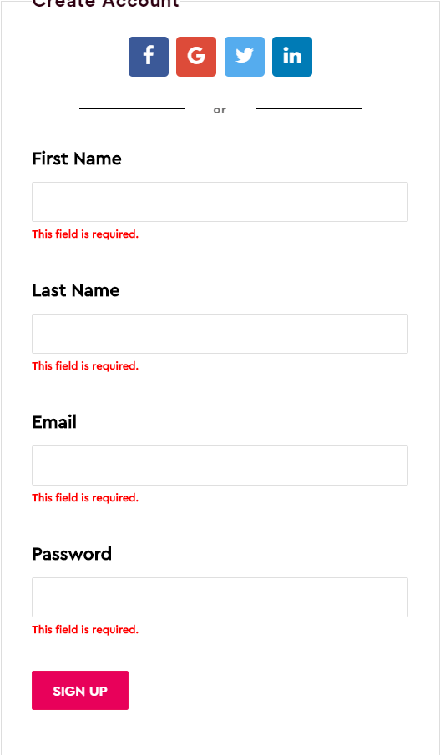

## User Registration Form (Sending Emails)

When a user fills out the registration form and then hits the submit button, provided that all the validation criteria were not violated, your website must then **send a welcome email message to the user’s email address and then redirect the user to a dashboard page.** For now, the dashboard page should contain information welcoming the user and should be properly styled.

## Git, GitHub and Heroku

Your web application must be pushed to a remote GitHub or Bitbucket repository on your account. Please note that **you must set your remote repository to private** and then add me as a collaborator so I can view your web application. Lastly, you are required to deploy the working web application to Heroku.

## Rubric

|  |  |  |  |
| --- | --- | --- | --- |
| **Criteria** | **Not Implemented**  **0** | **Partially**  **Implemented**  **1** | **Fully**  **Implemented**  **2** |
| **Meal Product Page**   * Meal Packages Listing in a grid using Handlebars and the data module * Each meal package lists the required data using Handlebars and the data module |  |  |  |
| **Login form Validation**   * Username validation (checking for nulls) * Password validation (checking for nulls) * Error messages are styled and are styled properly |  |  |  |
| **Registration form Validation**   * First Name validation (checking for nulls) * Last Name validation (checking for nulls) * Email validation (checking for nulls) * Password validation (checking for nulls) * Advance Validation Criteria 1 * Advance Validation Criteria 2 * Error messages are styled and are styled properly |  |  |  |
| **Email**   * Email is sent to the user’s email when the user fills out the registration form and hits the submit button. * User is redirected to a dashboard page * Dashboard page is styled |  |  |  |
| GitHub & Heroku   * You made at least 4 reasonable commits to GitHub or Bitbucket in private project * Your web app was successfully deployed to Heroku | **0**  **0** | **1** | **2**  **5** |
| Responsive Design   * Overall site is looks polished on all devices, specifically on smartphones, tablets, and large screens | **0** | **3** | **6** |

**Total: 45 MARKS**

**Assignment Submission**

* Before you submit, consider updating your css file, e.g. **site.css,** to provide additional style to the pages in your app. Black, White and Gray is boring, so why not add some cool colors and fonts (maybe something from [Google Fonts](https://fonts.google.com/))? This is your app for the semester, you should personalize it!
* Next, Add the following declaration at the top of your **server.js** file:

/*********************************************************************************  
* WEB322 – Assignment 02  
* I declare that this assignment is my own work in accordance with Seneca Academic Policy. No part * of this assignment has been copied manually or electronically from any other source   
* (including 3rd party web sites) or distributed to other students.  
*   
* Name: ______________________ Student ID: ________________ Date: __________________  
*  
* Online (Heroku, https://...) Link: ___________________________________________________  
*

* GitHub or Bitbucket repo Link: ___________________________________________________  
*  
********************************************************************************/

* Compress (.zip) your project folder and submit the .zip file to My.Seneca under   
  **Assignments** -> **Assignment** 2

**Important Note:**

* **NO LATE SUBMISSIONS** for assignments. Late assignment submissions will not be accepted and will receive a **grade of zero (0)**.
* After the end (11:59PM) of the due date, the assignment submission link on My.Seneca will no longer be available.
* Submitted assignments must run locally, ie: start up errors causing the assignment/app to fail on startup will result in a **grade of zero (0)** for the assignment.
* Posting your assignment solutions anywhere online, e.g. GitHub/Bitbucket, as public project constitutes **a violation of Seneca College’s Academic Integrity Policy**.

**THE END**